**1. INTRODUCTION**

**INTRODUCTION**

AR superimposes computer-generated images on a user’s camera-screen-view of the real world. Pokémon Go proved to be the catalyst and a game changer for AR. Following the resounding success of Pokémon Go, game developers readjusted their games in order to add and adapt the new technological trend- AR. Augmented Reality helps in creating a combined view for the player, which is an amalgamation of the real world and virtual images created by the computer.

In these prospects, we will consider the benefits of the Augmented Reality. Augmented reality is a technology that works on computer “vision based recognition algorithms” which helps in adding intense sound, video, graphics and even smell. All the real world objects are added using the camera of the user’s device. Benefits derived from AR games are endless. Normal people (non-fanatics) are beginning to understand what it is like to play games using smartphones. Games have reached another level of sophistication, which is helping to engage the millennial generation. Another major application has been stimulation games. AR makes that cockpit or cabin feel real to the gamer and helps improve their real-life abilities in a safe environment. Similarly, it can help soldiers, drivers, and students to enhance their skills. So along with entertaining, AR games are proving to be a great learning tool as well.

1. **Problem Definition**

Developing a multiplayer gaming module is a very challenging task in itself. Provided that the challenge is developing the game using the newest technology of augmented reality. The users will have to play using their devices which will connect with each other via broadcasting and networking module. This leads to the connection between the users. The common method of networking in this domain is it has never been performed before. Also deploying the virtual objects in the real world scenario as well as interacting using these objects in a 3D experience is a challenge that must be dealt with.

The purpose of this system is to use networking in the context of Augmented reality and thereby connect two users under strict time constraints . This system deploys the virtual objects using the camera of the associated devices.

**Problem Statement:**

To develop a multiplayer interaction application using augmented reality which will take a marker-based recognition image using camera device and will provide virtual interaction between users.

1. **Aim and Objective of the Project**

The project’s scope is to build an augmented reality based multi-player user interaction system which helps users to connect to each other using their smartphones and deploy their virtual objects in real world.

The system is proposed to have the following objectives along with functional requirements.

1. To create an adaptable system that can be used easily to connect multiple users.
2. To develop android application for users to experience 3D gaming experience using augmented reality.
3. To maintain the interconnectivity between the beyblade objects and users.
4. To use smartphone camera to detect smooth ground plane to deploy the virtual objects in real world.
5. **Scope and Limitations of the Project**

The project’s scope is to build an Augmented reality based multiple user interaction system which helps users to connect automatically in the augmented reality world using android application. Virtual object identification and deployment can be checked through the network module. This system provides an effective solution to explore the gaming dimensionality in the augmented reality scenario. It provides new trends in the domain of finding solutions for various real life problems using augmented reality and also it eliminates unnecessary real life hard work of interaction in the real world too. So it reduces the time and it is even a cost effective alternative.

The proposed work will use the Computer Vision technology to determine the surface on which the object will be deployed. The proposed work will explore the multi-user network interaction dimension and will use it to connect the smartphones. The proposed project will involve two user communication through the applications installed on their respective smartphones.

1. **Timeline of the Project**

Process Model used: Waterfall Model

In waterfall model, phases are organized in linear order. In this model project begins with feasibility analysis. Upon successfully demonstrating the feasibility of project, the requirements analysis and project planning begins. The design starts after the requirement analysis is complete and coding begins after the design is complete. Once the programming is completed the code is integrated and testing is done. Upon successful completion of testing, the system is installed. After this, the regular operation and maintenance of the system takes place.

The following documents generally form a reasonable set that should be produced in each project:

* Requirements document
* Project plan
* Design document (architecture, system and detailed)
* Test plan and test reports
* Final code
* Software manuals (e.g. user, installation )

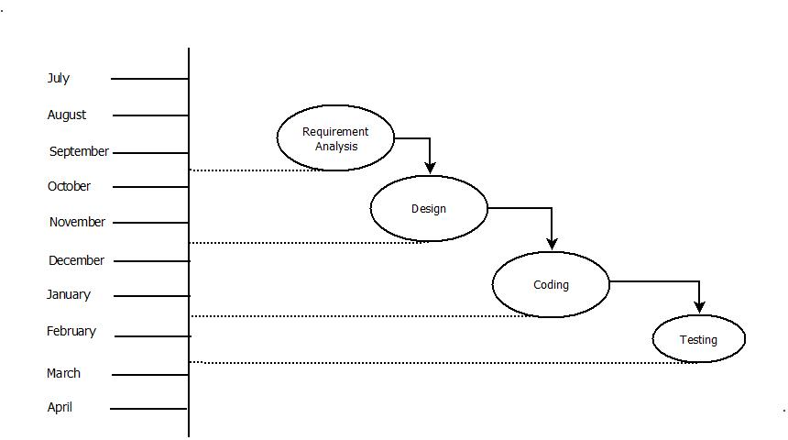

**Fig. Project Timeline**

1. **Project Cost**

**Hardware Cost:**

|  |  |  |  |
| --- | --- | --- | --- |
| **Sr.No** | **Component** | **Quantity*price** | **Price** |
| 1 | Computer System | 2*39000 | 78000 |
| 2 | Android smartphone | 2*12000 | 24000 |
| 3 | RJ45 Cable | 1*150 | 150 |
| 4 | USB Cable | 1*180 | 180 |
| 5 | Other Material | 1*250 | 250 |
| **Total** | | | **1,02,580** |

**Cost estimation based on COCOMO model**

In this project the Cost Estimation based on COCOMO (Constructive Cost Model) the formula for this Model is follows:

**Effort = Constant * (Size) scale factor * Effort Multiplier**

* Effort in terms of person-months
* Constant : 2.45 in 1998 based on Organic Mode
* Size : Estimated size in KLOC
* Scale Factor : Combined process factors
* Effort Multiplier (EM) : Combined effort factors

The basic COCOMO equations takes the form:

* Effort Applied (E) = ab (KLOC)bb [man-months]
* Development Time (D) =cb (Effort Applied)db [months]
* People required (P) = Effort Applied / Development Time [count]

Where, KLOC is the estimated number of delivered lines (expressed in thousands) of code for project,

The coefficients ab, bb, cb and db are given in the following table:

|  |  |  |  |  |
| --- | --- | --- | --- | --- |
| **Software Project** | **ab** | **bb** | **cb** | **db** |
| **Organic** | 2.4 | 1.05 | 2.5 | 0.38 |
| **Semi-detached** | 3.0 | 1.12 | 2.5 | 0.35 |
| **Embedded** | 3.6 | 1.20 | 2.5 | 0.32 |

**Organic Mode**

Effort Applied (E) = 2.4*(8.3)1.5 = 57.38 Man-months

Development Time (D) = 2.5*57.383.8 = 18.08 months

People required (P) = 57.38/8.08 = 4.84 ~ 5 People

Productivity: = 186 =

**2. BACKGROUND STUDY**

**&**

**LITERATURE REVIEW**

1. **Literature Overview**

A substantial amount of research is being done in the field of Augmented reality and the possible advantages it may have if rightfully utilized in the betterment of the community. Following are some of the papers:

[1] Ms.Akil H.Sayyad & Prof. S.A.Shinde**,** Sep 2015, proposed a white paper under International Research Journal of Engineering and Technology (IRJET) on Augmented Reality Based Mobile Tour Guide System on May 2016.

Critical appraisal:

The research has been praised by many fellow researchers. It also connects to the idea of initiating a new augmented world in terms of Google Maps. Google Maps can include this technology as a component module and thereby enhance the user experience. The International Research Journal of Engineering and Technology (IRJET) also recognised this paper and also agreed to invest a substantial amount of funds if a viable solution to implement this idea is found.

Abstract:

The system is derived from the idea of augmented reality. They have introduced a new tour guide system utilizing augmented reality in mobile environment by considering limitations of paper based and mobile based tour guide systems. This system consists of tourist point of interest and properly guide tourist. The system uses the GPS technology consisting of viewing similar to that of Google Maps to precisely detect the user location. The cloud data is used to store the buffer of potential data that will likely be requested by the user. The use of Machine learning facilitates implementation of a large- scale system at low cost. The system provides a mechanism to prevent disputes in the simulation and helps to recognise and object using the smartphone. After logging into the system, the user can choose a suitable location or a real world object. Information on the selected location will be conﬁrmed to the user via notiﬁcation. Then, the system updates the user about the details of the location identified by the user. If after a certain period of pending time the system determines that user is offline then it changes the status to available. The system will help plot the location of object identified using the smartphone camera in real time and can support the business with hourly parking charges.

[2] Richard Sala, Santi Ristol, July 2012, IJAREEIE, proposed a Augmented Reality Based Flood simulation System under ATOS Scientific Community on Mobile Augmented Reality.

Critical appraisal:

The research pertaining flood simulation and use of GPS technology along with Cloud Computing is a new concept which is actually implementable. The paper presented at the ATOS Scientific community was praised and also meant for implementation. The technology of augmented reality will be implemented using cloud computing which is a combination of greater possibilities. It will be a simulation software capable of determining the potential effects of Floods and the possible damages and repairs to be done.

Abstract:

The entire framework incorporates three modules: Cloud, Smartphone device and User. User must register in any of enrolled smartphone device and a unique user identification tag/ smart card will be assigned. To select the location of the flood affected region, user selects the location and sends request to cloud via smart phone, and also can view the respective selected area details. Cloud will calculate shortest distance between user & nearest water body in requested location, and simulate the flood reaction based on the water content and the respective weather condition over the years. They have stated the development of augmented reality in all the sectors of the industry and the position of in in the current state. According to their conclusion,” Atos sees augmented reality becoming a part of everyone’s reality in the next few years, transforming mobiles into advanced sensors and lives into connected networks. Augmented Reality Services will emerge from different sectors crossing over current niches to generate direct benefits to users, businesses and workers. Because users will need to download contents and information from the Internet, network performance and cost will be key. Indeed, the last market changes in flat-rate contracts may slow down AR adoption.

**3. REQUIREMENT ANALYSIS**

1. **Hardware and Software Requirements**

* **Minimum Hardware Requirements**
* **Processor :** Intel i3 or Higher
* **RAM :** 4GB or above
* **Project Hardware/ Devices :**

1. Android smartphone (Minimum 5.0 or above)
2. Computer (preferably laptop with above configurations)

* **Software Requirements**
* **Operating System :** windows 7 or above
* **Development IDE :** Unity 3D Studio, AutoCad Blender, Fusion 360o
* **Server :** Unity 3D engine
* **Utilities :** Vuforia, Wikitude SLAM technology

1. **External Interface**

* **Computer (preferably laptops)**:

The system requires the support of Unity 3D to build the application supported by the android application. The objects (Beyblades) are developed using the Blender software provided by the AutoCad.

* **Mobile application**-:

For interacting with the system and deployment of the virtual object in the real world scenario, mobile application is needed.

* **Server**:

One of the smartphones will act as the server in the client server architecture for the entire data interaction of the user. It processes all the data. It will broadcast the network packets

* **Client**:

One of the smartphones will act as the client in the client server architecture for the entire data interaction of the user. It processes all the data. It will receive the packets and perform the intercommunication.

1. **Functional Requirements**

The system is proposed to have the following modules along with functional requirement:

* Function to log on the user in the module.
* Function to sense the ground plane using ground plane detection.
* Function to deploy the object on the detected ground plane.
* Function to fetch the user data and user data from server to client mobile application.
* Function to save user data on the server.
* Function to display blade health status on mobile application.
* Function to display the winner of the battle.

1. **Performance Requirements**

The system is proposed to have the following performance requirement:

* The connection of multiple users depends on how many users are available and those users can connect and participate using third party hotspot.
* The mobile deployed server client architecture gives the user ability to connect and deploy the virtual objects.
* If one user terminates the gaming module, the other user will also be subsequently declared winner and the session will be terminated.
* The software is such that it will function under normal working conditions as specified and the connection will not terminate provided that the users are in the network range.
* To implement a system which will not crash throughout its implementation. This will be facilitated by the exception handling mechanism.
* To implement a system to detect the surface on which the object will be deployed by mean of identification.
* To implement a system capable on running on all the android based smartphones.

1. **Software system attributes**

There are a number of attributes of software that can serve as requirements. It is important that require attributes be specified so that their achievement can be objectively verified.

1. **Reliability**

The system will be able to process all work correctly and completely without being aborted. The data after each battle will be recorded and stored as it uses broadcasting and networking phenomena.

1. **Availability**

After the connection is established, the system will provide service without interruption and users will be able to interact with one another without and hindrance as the systems will stay connected using networking.

1. **Security**

System after connection is established will provide service without interruption and users will be able to interact with one another.

1. **Maintainability**

Regular updates are ensured using new builds every time any change is induced in the application.

1. **Portability**

The proposed android application is operating system dependent. It works on any android phone having version 4.0 or higher.

**4. SYSTEM DESIGN**

System design covers system architecture. System and the elements consist of design specification, for instance, use case diagram, activity diagram and so on, sample of those diagrams are included in this chapter.

## **Module Description:**

Below mentioned are the various diagrams of the proposed work. It will include the various modules as per the distribution of the tasks in various phases. Following are the modules:

1. **Network Establishment Module**

The Network Establishment Module will be the entry point of the proposed work. It will provide the connection between the users in order to facilitate the communication between the objects thereafter in the module.

1. **Interaction Module**

The Interaction Module will facilitate the connection and actual interaction of the objects of the proposed work. It will provide the base for the objects for interaction and this will be supported using the network connection.

1. **Object Module**

The Object Module as the name suggests will be the repository of the proposed work. It will comprise of the objects developed for the proposed work. These objects will constitute the back end of the project.

1. **Storage Module**

The Storage Module as the name suggests will be the storage of the proposed work. It will store the objects developed for the proposed work. These objects along with the battle details will constitute the storage repository of the project.

1. **Result Module**

The Result Module as the name suggests will serve the result of the proposed work. It will comprise of scores of the individuals.

1. **Architectural Design**

Interaction

Module

Data-Wikitude

Storage Module

Network

Module

Result (Output) Module

Object (Ground plane detection)

Module

**Fig. System architecture**

1. **User Interface Design**

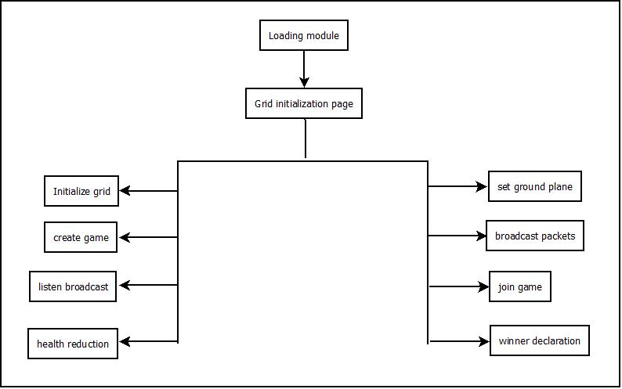

**Fig. User Interface Diagram**

1. **System Modelling**
2. **Class Diagram**

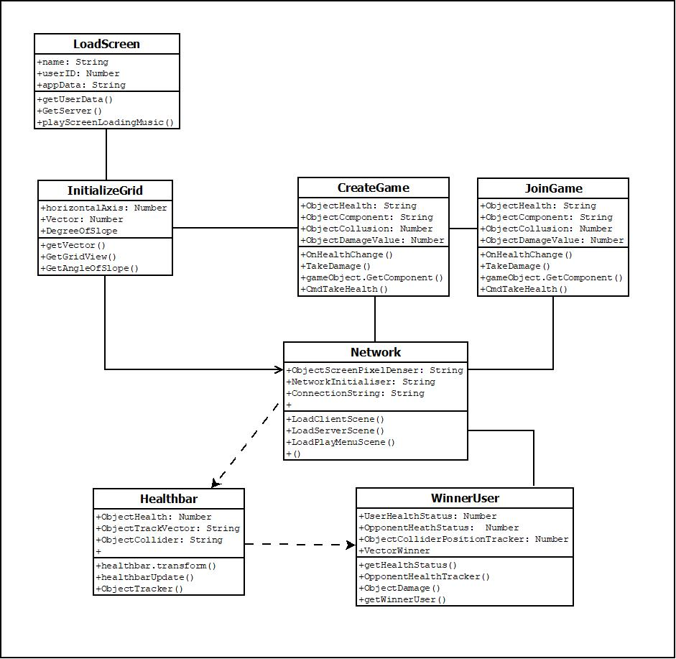

**Fig. Class Diagram**

1. **Dataflow Diagram**

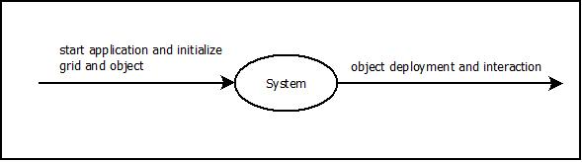

**Fig. DFD Level 0 Diagram**

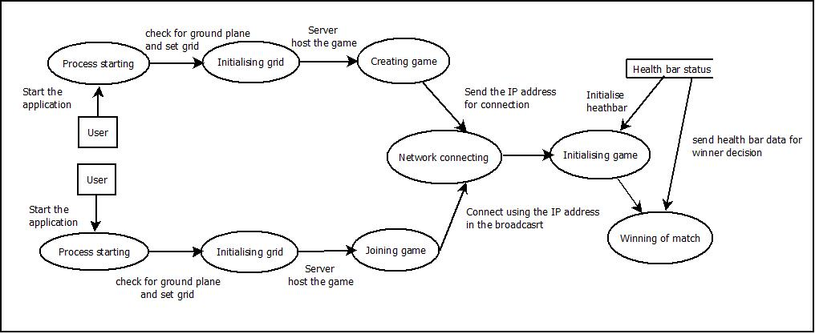

**Fig. DFD Level 1 Diagram**

**Fig. DFD Level 1 Diagram**

1. 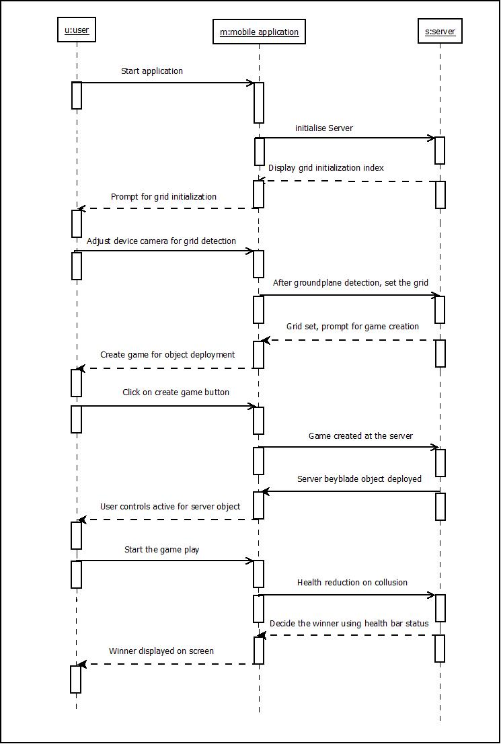**Sequence Diagram**

**Fig. Sequence Diagram (Server)**

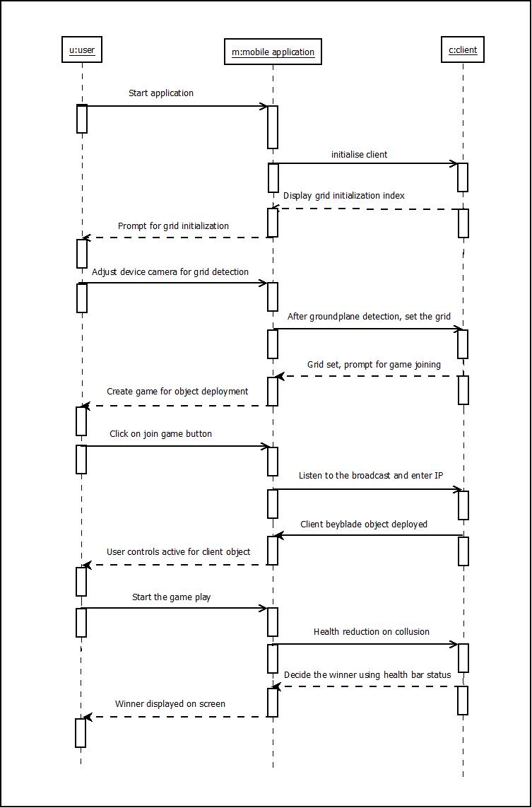

**Fig. Sequence Diagram (Client)**

**Continue Fig. Sequence Diagram**

**Collaboration Diagram**

18. Winner declared

14. Opponent blade deployed

10. Broadcast packet containing IP address

6. Initialise grid and set grid for object deployment

2. Load the background data

s: server

m: mobile application

3. The background data loaded on server and client

7. Grid set and object will be deployed on the grid

11. Other user listens broadcast and connects game.

15. Health bars deployed for both blade objects

17. Reduction in health

13. Wait for the opponent blade to be deployed

9. Create game button click

5. Hold the device at appropriate position and initialise grid

1. Start the application

16. Health reduced after collusion detection

12. Sever user blade object deployed

8. Create/Host game and allow other user to connect

4. Display the initialise button to the user

u: user

**Fig. Collaboration Diagram**

1. 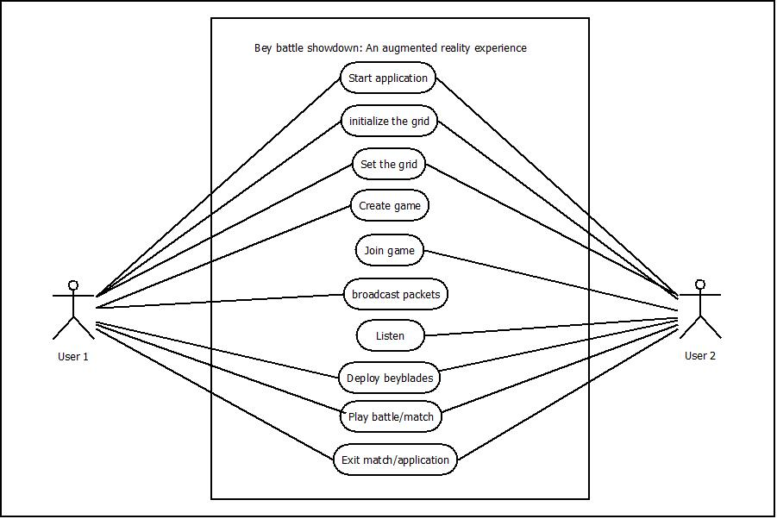**Use-Case Diagram**

**Fig. Use-Case Diagram**

1. **Activity Diagram**

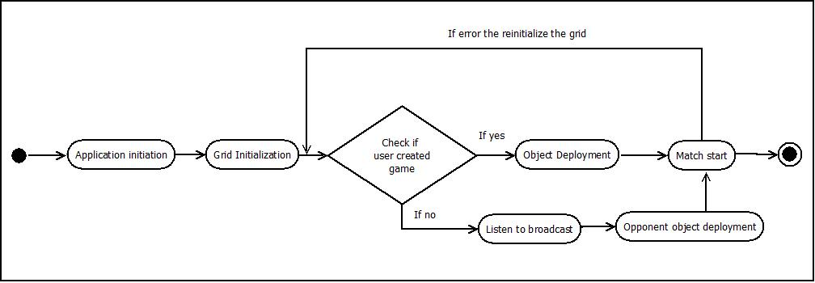

**Fig. Activity Diagram**

1. **State Chart Diagram**

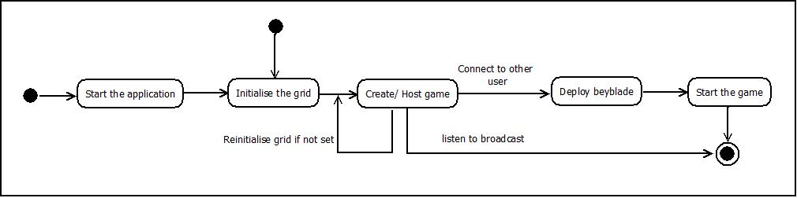

**Fig. State Chart Diagram**

1. **Component Diagram**

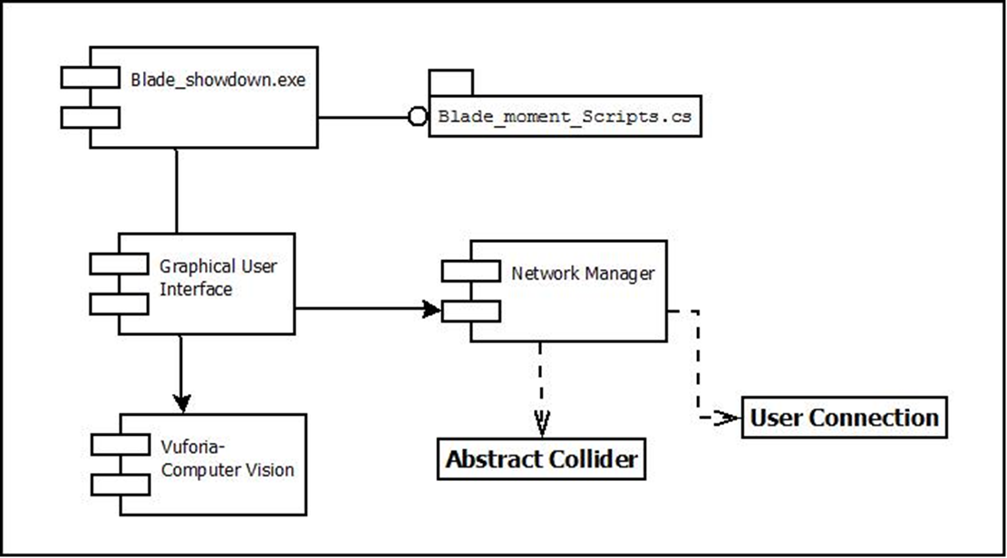

**Fig. Component Diagram**

1. **Deployment Diagram**

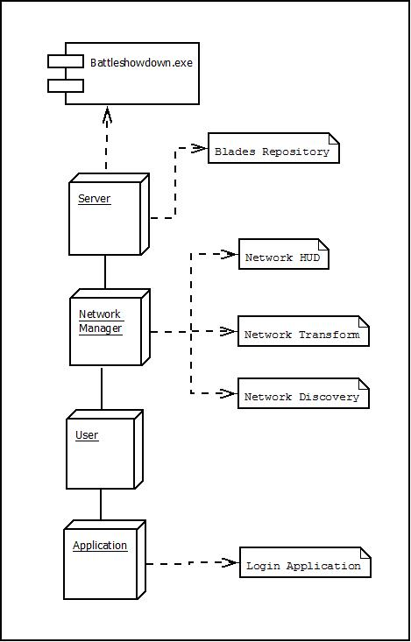****

**Fig. Deployment Diagram**

1. **Algorithmic Description of each modules**
2. **Login module**
3. **Initiation**

Step 1: Start

Step 2: If user is already authorised, go to step 4

Else If User should install the bey-battle showdown game on the smartphone device

Go to step 3

Else

1. Start the hotspot of the smartphone device
2. Select the game icon and start the game
3. Select create game to initialise the game

Step 3: Wait for the other user to listen to the broadcast and connect

Step 4: If user is authenticated, allow user to connect

Else

Deny exit

Step 5: Stop

1. **Game play and broadcast initiation**
   1. **Broadcast Initiation**

Step 1: Start

Step 2: Select one of the options.

* + 1. Create game
    2. Host game

Step 3: If option 1 is selected then,

Create a new game and broadcast the network IP address containing match id, IP address of host.

Step 4: If option 2 is selected then,

1. Select join game
2. Click on join game button
3. Receive the broadcast
   1. Get the IP address from the broadcast
   2. Enter the IP address and click on connect

Else

Try again to connect to the user or retry by reinitialising the grid and repeating from step 2

Step 5: Stop

1. **Game play**

Step 1: Start

Step 2: Attack the bey blade object deployed by the corresponding opponent.

1. Use boost provided by boost button
2. Check for the health indicated by the health bar

Step 3: If health of your object goes down to zero then,

The opponent will be declared as the official winner of the match.

Else

Try again to connect to the user or retry by reinitialising the grid and repeating from step 2.

Step 5: Stop

1. **Connection between Users via broadcasting and networking**

Step 1: Start

Step 2: Initialise the grid detection algorithm

Click on initialise grid button once the ground plane is detected.

Step 3: Listen to the broadcast.

Click on the listen button and then the broadcasted IP address present in the packet is detected

Step 4: Initialise the connection on the same IP address

1. Accept packet from the connected user
2. Set all values of each state as per the packet information (IP address) for the corresponding opponent player object
3. Check for the change in state, note the same.
4. Collect all the information and state of the corresponding user device.
5. Wrap the user data into network packet and send the packet as a reply or acknowledgement to the broadcast.

Else

Try again to connect to the user or retry by reinitialising the grid and repeating from step 2.

Step 5: Stop

**5. IMPLEMENTATION**

1. **Environmental Setting For Running The Project**

Software required for implementing the project are Unity 3D Studio, Blender 3D and Android Studio.

High speed mobile hotspot connectivity should be available for fetching the data in less time.

1. **Detailed Description of Modules**

* **Blade rotation**
* **void transform.rotate()**
* The function executes multiple times throughout the gaming module in the program.
* The function is used to set blade rotation speed and the blade movement.
* We need to initiate the vector for the horizontal movement of the blade.
* The server sets the default speed and movement using this function.
* **void Start()**
* blade.activeSelf() function is called here to check the blade presence.
* client.connect() function is used to send data to mysql.
* transformPosition() function is used to get data for blade movement and subsequently update both systems.
* isLocalPlayer() method to identify the local user.
* **void Update()**
* trails.setActive() function is used here for low and high movement of the trailing blade and the attacking blade.
* OnCollusionEnter() method is used here for calculating the health reduction after the blade collusion occurs.
* **Gameplay module:**
* **void healthNetworkBehaviour()**
* OnHealthChange() function is called here to check the blade health and resuce health bar value.
* TakeDamage(int amount) function is used to get the blade damage data and send it to both server and client.
* gameObject.GetComponent() function is used to get data for blade movement and subsequently update both systems.
* CmdTakeHealth() method to reduce player health.
* **void HealthbarUpdate()**
* healthbar.transform.localPosition() function is used here for low and high movement of the health bare module.
* trackerScript OnEnable() method is used here for calculating the health reduction after the blade collusion occurs.

**Network modules:**

* **void loadClient()**
* void GameObject.Find("Network UI") function is called here to start the broadcasting of the module packets.
* void LoadClientScene(int index) function is called here to load the initial client screen on start of the application of client side.
* void Start_Custom_Client() function is called here to load the custom client and start the game.
* void OnClientConnect(NetworkConnection conn) method uses the nwtwork connection string to connect the client to the server.
* **void loadServer()**
* void GameObject.Find("Network UI") function is called here to start the broadcasting of the module packets.
* void LoadClientScene(int index) function is called here to load the initial client screen on start of the application of server side.

**Support modules:**

* **void LoadScreen ()**
* void ScreenLoader(int index) function is called here to load the initial screen on start of the application.
* void LoadClientScene(int index) function is called here to load the initial screen on start of the application of client side.
* void LoadServerScene(int index) function is called here to load the initial screen on start of the application on server side.
* void LoadPlayMenuScene() method to display the menu bar on the home screen.
* **void SoundController()**
* void PlayButtonSound() function is used here for controlling the sound of the application as per the module.
* void PlayExitSound() method is used here for deploying the exit game sound as the user exits the game.
* **Mobile Server**

All the gameplay data collected by the game module of the user smartphone device application is send to the corresponding other user over the Wi-Fi connectivity. This data is accessed by gaming module using android application.

* **Mobile Client**

The other user smartphone connected to the first user’s hotspot connectivity acts as the client and requests for information and after getting the information acts upon it thereby giving an uninterrupted gaming experience.

* **Mobile Application**
* Details of all users and game play details is stored on the mobile server which is created. This server is further used for user connection, game play and updating the status subsequently.
* When user connects to other user, the data from server is fetched after authentication of user.
* When user clicks on the ‘create game’ button, the mobile application enables a network broadcast via the hotspot connection. The IP address packets are broadcasted and other user connects using the IP address provided in the packet
* If user chooses join game, then the user waits for the broadcast IP address, after getting the address, the user chooses join game to start the game module.
* The bey blade movement as well as their respective health status is displayed after user starts the game, then he/she can see the health status. The status data is fetched from server, as given to the client and vice versa.
* The navigation buttons are displayed at bottom right side of the screen. If the user wishes to terminate the game and exit the application, he/ she can simply press the back or exit button. This will cause the user to exit the current screen and return to the main screen or pressing exit button will cause the user to exit from the application.
* If user selects the winner module tab he can see the current winner of the battle.

**6. INTEGRATION & TESTING**

1. **Description of the Integration Module**

**Testing – These are some sample test case examples which are performed in our project**

**Unit Testing:**

Unit testing is a level of software testing where in individual modules of software are tested.

|  |  |  |  |  |  |
| --- | --- | --- | --- | --- | --- |
| **Sr. No.** | **Field to test** | **Test Data/ Action** | **Expected Result** | **Actual Result** | **Comment** |
| 1 | Loading screen | Start application | The screen should run until next scene data loads | Next scene loads after loading screen | Pass |
| 2 | Ground plane detection | Deployment of grid on real world surface | Grid should turn green when appropriate ground plane is detected | Grid turns green when appropriate ground plane is detected | Pass |
| 3 | Initialising the Grid | Click the initialise button | The grid should get fixed on the plane detected | The grid gets fixed on the plane detected | Pass |
| 4 | Deployment of Arena | Arena to be deployed on screen | Arena to be deployed on screen | Arena is deployed on screen and sets as per the detected ground plane | Pass |
| 5 | Create game | Click on the create button | Blade should be deployed and host broadcast should be started | Blade is deployed and host broadcast is started | Pass |
| 6 | Host blade deployment | NA | After hosting game, the blade should be deployed | After hosting game, the blade got deployed | Pass |
| 6 | Join game | Click on the join game button | The other player should listen to the broadcast and should join the game | The other player listened to the broadcast and joined the game | Pass |
| 7 | Client Blade deployment | NA | After joining the game, the blade should be deployed | After joining the game, the blade got deployed | Pass |
| 8 | Health bar deployed | NA | After both blades are deployed, opponent health bar should be displayed on upper right corner for respective players. | After both blades are deployed, opponent health bar got displayed on upper right corner for respective players. | Pass |
| 9 | Health Management | Collusion detection | Depending on the user attacks and movements, the health should be modified | Depending on the user attacks and movements, the health got modified | Pass |
| 10 | Winning screen | NA | When the health of any one player reduces to zero, the other one should be declared as the winner. | When the health of one player reduced to zero, the other one was declared as the winner | Pass |

**Integration Testing:**

In integration testing, all the modules are integrated to a single module. After integrating, testing is performed on the final module to verify the correctness of code.

**System Testing:**

The testing of entire system is performed in system testing and the reference used is the software requirement document. Purpose of this testing is to check whether all the conditions are satisfied and all requirement are met

The document (SRS) is the file which collects the requirements from the users and is used to build the product, with the help of this document several test are taken after the application is developed. In our project the system testing has been successfully done by using the SRS documentation.

**7. PERFORMANCE ANALYSIS**

1. Computer Vision modules are for identifying the ground plane and detecting the surface on which the grid is to be deployed. It performs well in the range between 1 m to 4 metre at normal rom[om conditions. We operated this sensor using smartphone camera at minimum range 3 cm apart from sensor at normal temperature.

We are currently using two smartphones and their subsequent device cameras to detect the ground plane and deploy the objects.

1. The networking module in both devices serve as the client server architecture. One of them is responsible for hosting the game using the Mobile hotspot, an inbuilt feature of android smartphones.
2. Android smartphone thread management and quad core processor is used for data transfer from client to server. It is connected through Wi-Fi to provide network connectivity to game installed on the devices.
3. Mobile Hotspot Connection is used for internet connectivity between client and server.

It works fine at normal user connection and speed of game play.

The sensed data by ultrasonic sensor is transfer to the server by using Ethernet shield. After every 5 seconds data is sensed and appropriate status is updated in the database located on server. It takes approximately 5 – 6 seconds to update data. The time needed to access the data solely depends on the internet speed provided to the Ethernet shield and to the NodeMCU.

**Android:**

* For logging it takes 5-6 seconds to connect users at normal speed of hotspot connectivity.
* For loading the grid and actual game module it takes 2-10 second. The average CPU usage is up to 28%. The overall average memory usage is up to 230 MB.
* Time required to parse the intermediate coordinates is up to 2-10 second.

**8. APPLICATION**

The project’s scope is to build an Augmented Reality based multiplayer user interaction system which helps users to connect via the networking and broadcasting module using android application.

This system provides an effective solution to use the augmented reality experience in a multi user domain. It helps user to connect with other user and interact virtually using augmented objects. So it reduces the time and it is cost effective also.

This technology can be used for many suitable applications in many fields of engineering like Non-destructive testing, flood simulation systems as well as medical sciences like cell modulation and testing.

1. **INSTALLATION GUIDE**

**&**

**USER MANUAL**

* The user must have application to use this service.
* The user must install the application to access the services and should possibly have unity 3D software installed to authenticate application build.
* The user mobile must have connected to the Mobile Hotspot and connect to the other user smartphone device to start the game.
* User must listen to the IP address and start the game.

**User Manual**

The user consists of steps to access and interact with “Bey Battle showdown” application.

1. **Starting Page**

This is the Bey battle showdown application Starting page.

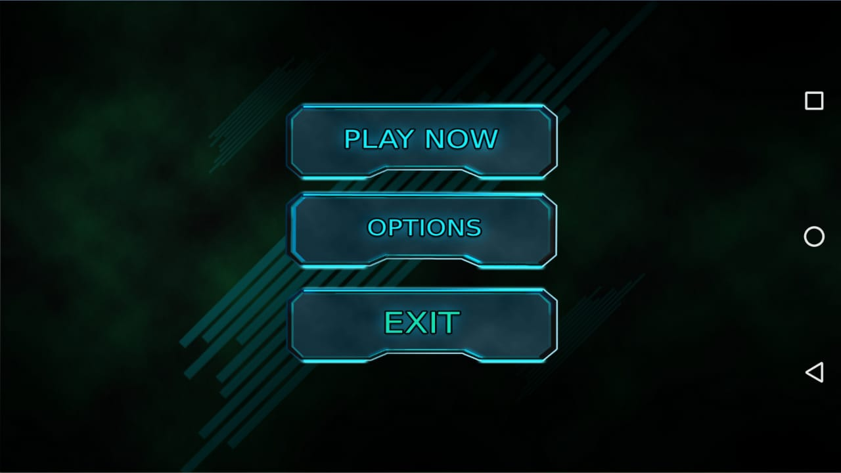

1. **Select Game**

Here, the user can either choose to host a game or to join the game (either be the hosting server or be the joining client).

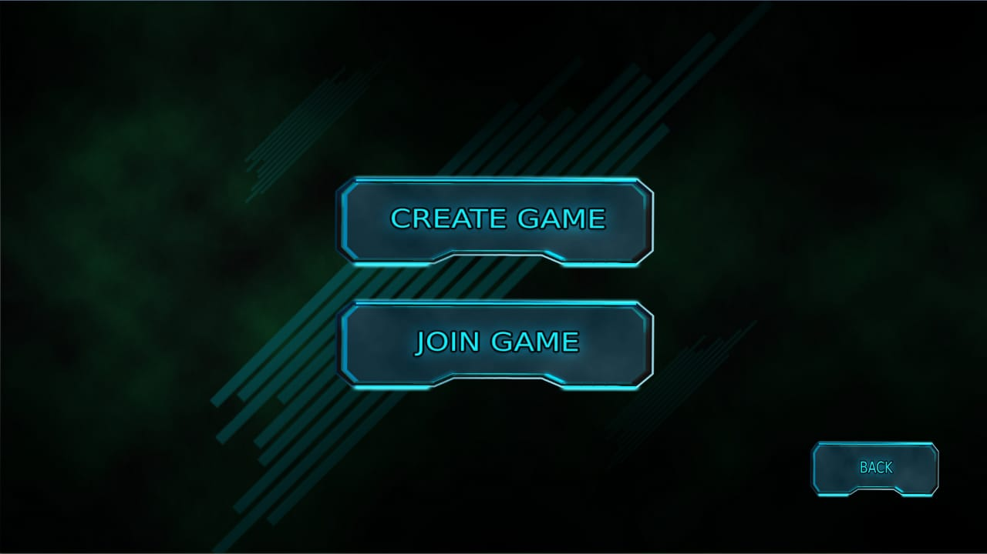

1. **Create Game**

Here, the user creates the game and waits for other user to connect.

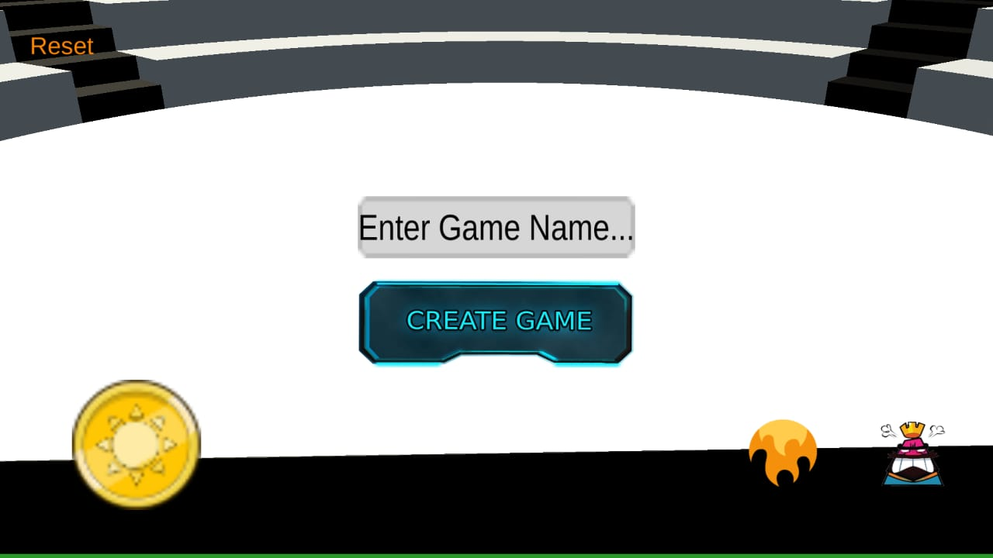

**4. Initialise Grid (Ground plane detection and setting the grid)**

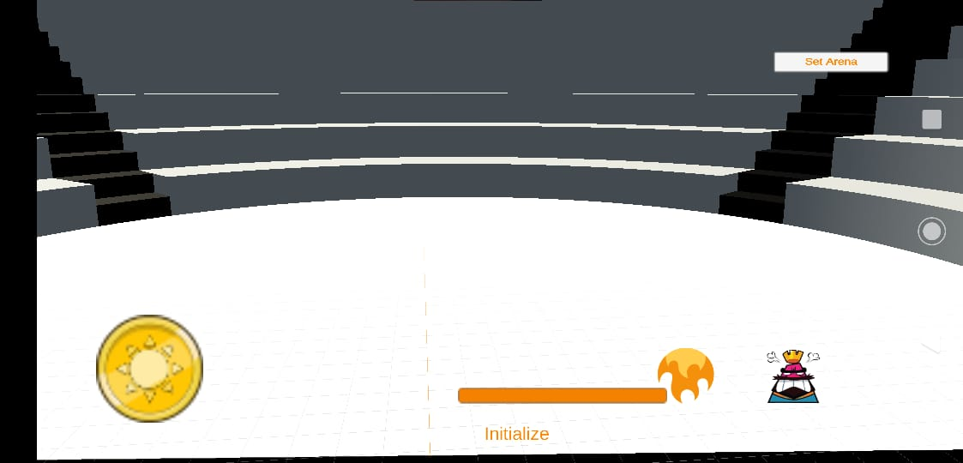Here user can set the grid on which the object will be deployed

**5. Join Game (Listen)**

Here user can see the broadcasted Game Name of the corresponding user.

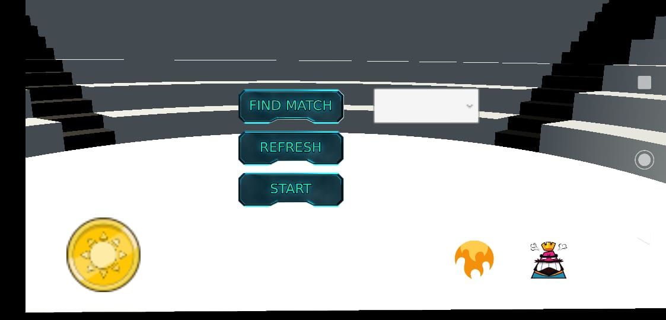

**6. Join game (Join)**

1. Here user can see the join button and after clicking the same, the user will be directed to the game play module.



1. If you do not connect to any other user, it also has a feature of a solo game play, using this the user can harness his/ her strengths and practice.

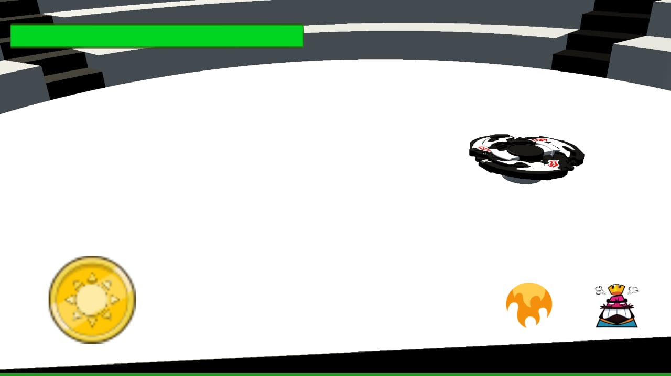

**7. Game play module**

On this page, the user can see his/ her personal blade object (virtual object) and if connected to other user, then corresponding blade object of the other user also gets deployed on the screen.

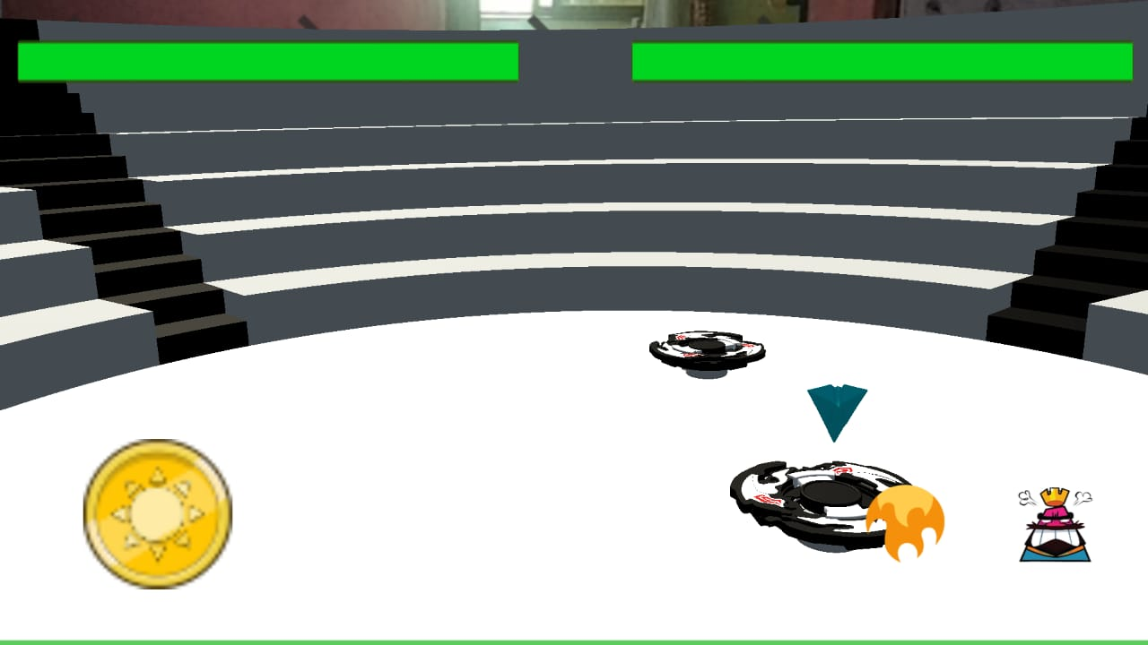

**8. Winner User Page**

Here user can see the statistic of the match, the user of the surviving blade object will be termed as the Winner of the match.





**10. DECLARATION OF ETHICS**

As a Computer Science and Engineering student, I believe it is unethical to,

1. Surf the internet for personal interest and non-class related purpose during classes.
2. Make a copy of software for personal or commercial use.
3. Make a copy of a software for friend.
4. Loan CDs of software to friends.
5. Download pirated software from internet.
6. Distribute pirated software from internet.
7. Buy software with a single user license and then install it on multiple computers.
8. Share a pirated copy of software.
9. Install a pirated copy of a software.

**11. REFERENCES**

[1] Cynthia Allum, Elyssa Goldberg, Matthew Weinberg, Rashmi Bhagwat,”State of Augmented reality” in “Augmented Reality- a dimenaional approach”, November 2015, pp 133- 180.

[2] Richard Sala & Santi Ristol, “Mobile Augmented Reality” in “The study of Google Glass” July 2012, page no.: 9- 16.

[3] Ms.Akil H.Sayyad & Prof. S.A.Shinde,“ Augmented Reality Based Mobile Tour Guide System” on May 2016, section. 3, pp 279- 383.

[4] Dr Martina Reiter,” Engterprise Training with Augmented Reality”,“Reprinted in Human Computer Interaction(ICT 225) Reading and Lecture Notes, Vol1, Murdoch: Murdoch University, 2013.